

**Online Voting System**

G Charan Kumar Naidu

Computer Science and Engineering

Kalasalingam Academy of Research and Education

B Manoj kumar reddy

Computer Science and Engineering

Kalasalingam Academy of Research and Education

K Charan kumar

Computer Science and Engineering

Kalasalingam Academy of Research and Education

B Venu

Computer Science and Engineering

Kalasalingam Academy of Research and Education

**Online Voting System**

## Abstract

A secure and user-friendly online voting system is currently being designed. The online voting mechanism is designed to allow voters from all around the world to choose their representatives. Here in our planet, we have the choice of holding an election using paper ballots or an automated ballot election. Elections using electronic ballot have taken the place of recent years, the norm. Currently, electronic voting is also practised. The ability to vote accurately and directly online has enabled the system to advance to the point where it can replace the current online polling system. . When registering to vote online, a user enters their Voter ID, email address, password, and thumb (because these things are all unique to them). Every user of this system has only one vote, and if they cast it more than once, it will be regarded as illegitimate. We can speed things up and by using this online voting technique, you may save time, money, and safety.

## Introduction

In contrast to an offline voting system, our project focuses on an online voting system utilising JAVA and MYSQL that allows us to shorten voting times and assures voting is secure. For this voting system, voters can sign in using their Voter ID and Password. The admin will also have separate page where he/she can control the entire voting system and managing over all process and taking care of the database. The Admin can sign in using Admin ID and Password. The admin has the access to all the details of the voters,candidates list and details and can count the number of votes that a particular candidate have got and can declare the results.

**Existing System**

Existing system is a manual one in which users and the details of the candidates are stored in books. The users have to wait a long time in queues for voting. Wrong and unwanted votes are given. Counting of votes are done manually which takes lots of time and inaccurate counting is done. It is very difficult to maintain historical data. In the existing system, there is compulsory need in physical presence in the time of election polling. In the existing system, there is compulsory need in physical presence in the time of election polling or vote counting.

**Disadvantages of Existing System:**

* If elections are conducted in existing system model in the pandemic time, then there is sure spread of disease like COVID, which happened in the recent elections in India.
* It is difficult to maintain important information in books.
* More manual hours are needed for counting of votes.
* It is tedious to manage historical data which needs much space to keep all the information regarding the voters and the candidates.
* Voters have to wait in long queues for voting they have to travel long distances.

**Proposed System**

The Online Voting System is a software application which avoids more manual hours that need to spend in record keeping and calculating votes. Through this the users and the candidates are registered online. Their information is stored in the database the admin can easily access the details of the voters and the candidates. The voters are allowed to vote online they can even vote by sitting at home. Every User allowed to vote only once so there is no chance of duplicated votes. This application keeps the data in a centralized way which is available to all the users simultaneously. It is very easy to manage historical data in database. They can easily use the tool that decreases manual hours spending for normal things and hence increases the performance.

**Advantages of Proposed System:**

* Online voting system is user friendly and secure
* Reduces the time and money in conducting the offline elections
* Securing counting of the results.
* Reduce the cost of staff and the ballot boxes.
* No valid vote can be eliminated from the final tally.
* Not possible to alter a vote
* No valid vote can be counted
* Anyone can independently verify that counting was correct.
* Flexibility
* Mobility
* Convenience

**Module Description**

The first part of the project consists of the voter page. It will have ID and Password text fields ,after entering the ID and password and by clicking login the page checks the details of the Voter or Admin and verifies with the database that is created already in My SQL .When the details entered by the voter are correct the page moves to next page displaying the different candidates /parties names and symbols ,a button is provided for each candidate the voter can select can click only on one button and the result count is saved in the database. The another part of the project contains Admin page where the admin can enter the ID and Password ,when the details entered by the admin are correct it moves to another page where there is voter list and candidate list and can access the database at any time.By looking the database the admin declares the result of the voting.

**System Design**

**ADMIN**

**VOTER**

**VOTER ID**

**PASSWORD**

**ADMIN ID**

**PASSWORD**

**CANDIDATES LIST**

**VOTER LIST**

WINNER

**RESULTS**

**WINNER**

**VOTE**

**PARTIES SYMBOLS**

**CANDIDATES NAMES**

**Result Analysis**

***Strengths:*** The essence of the scientific results obtained by the current development is that the new system helps in understanding the dynamics that are considered while developing the system that is to be used for the public purposes in midst of various internal and external chal lenges. The development of the system required that not only the basic purpose of the system should be achieved, but it should be also considered that the new system is secure on end to end. The system development should be conducted considering the need of the users while taking care of their privacy issues. The current system will allow the government to con duct online elections. It will be easier for the government to conduct the election without engaging extra resources. The system will allow the voters to vote securely with end to end encryption.

***Opportunities:***The current system will be hugely use ful for the governments in conducting voting in vari ous locations around the country. The new system will likely open opportunities in other governmental depart ment at smaller to larger scale to conduct the voting. It can also be used by the public limited companies to conduct shareholder voting to select the next chairman for the organization.

***Threats:***The threats are in the form of hackers who might try to infiltrate the system to steal the voter data.

**Conclusion**

The use of online voting system is likely to improve if the governments of various countries make effort to educate their population. The use of online voting system will help in the easy management of most of the governmental activities and also facilitate the successful interaction with the citizens.The current article proposes an online voting system that is expected to be used by the government to conducting voting. The voters will cast votes by logging into the system which will be then summarized by the system automatically in the form of a table to know the result of the election.

**OUTPUT SCREENSHOT**

**HOME PAGE**

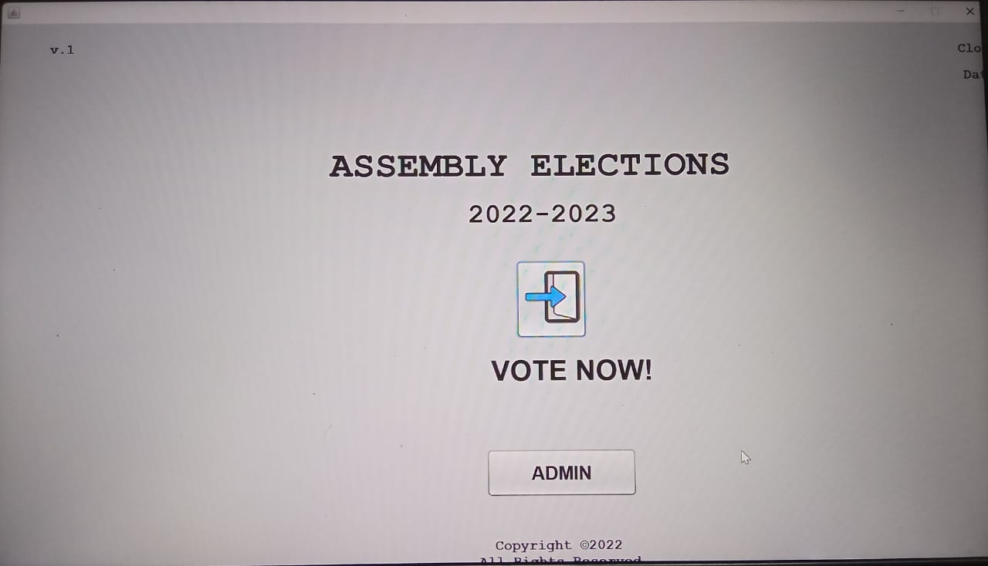

**ADMIN PAGE**

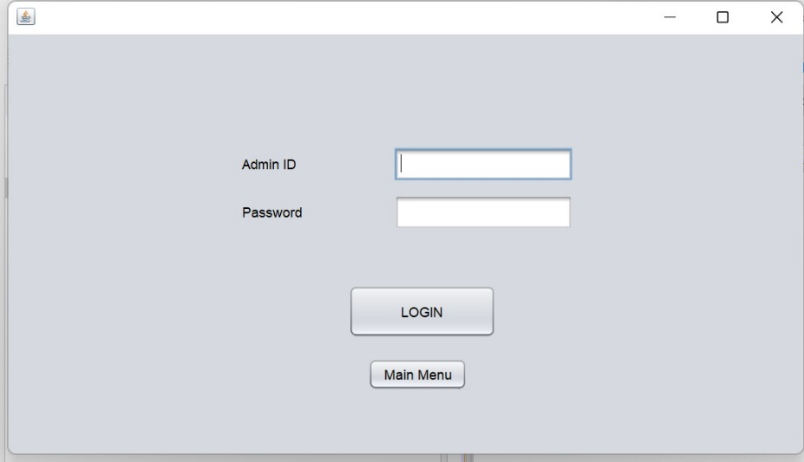

**ADMIN LOGIN**

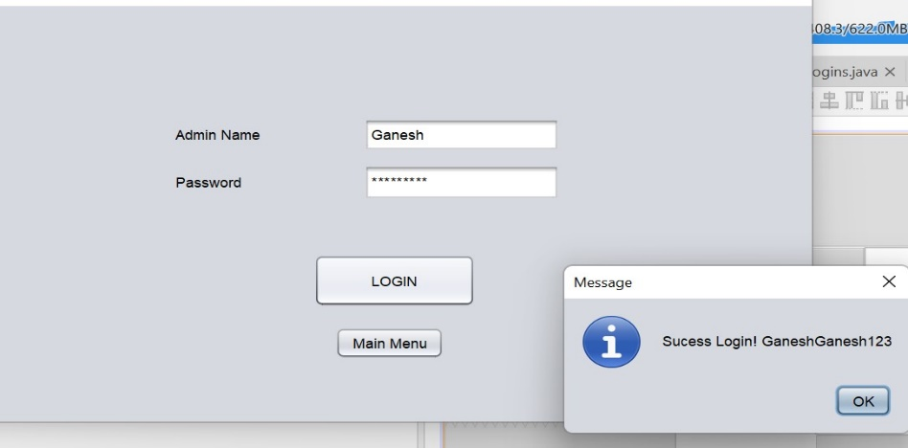

**ADMIN ACCESS**

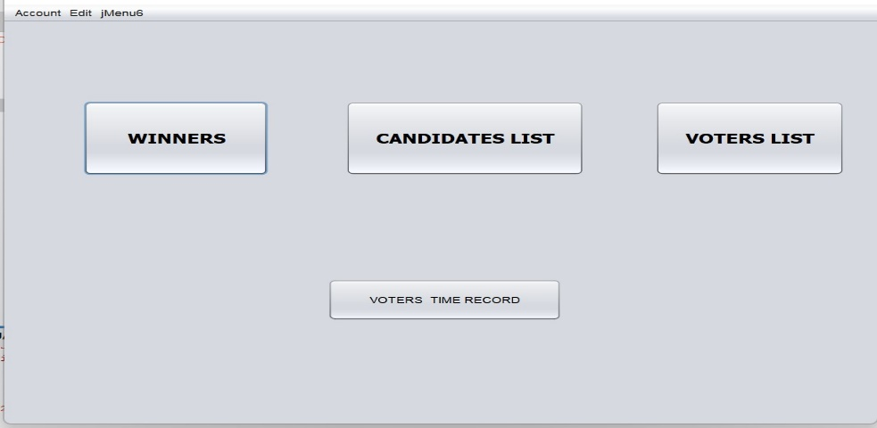

**VOTER PAGE**

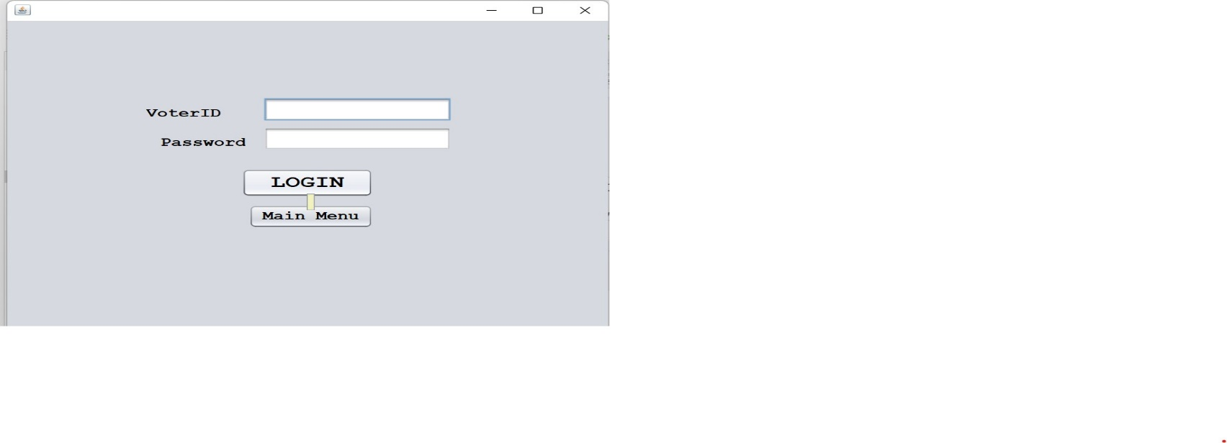

**VOTER LOGIN**

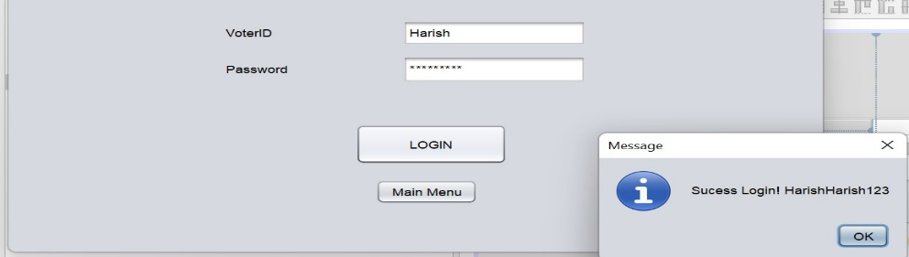

**CANDIDATE LIST**

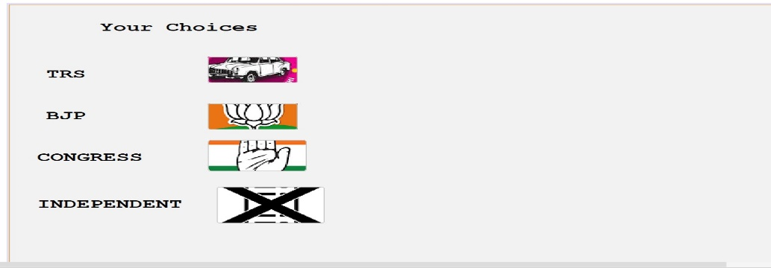

**VOTE CONFIRMATION**

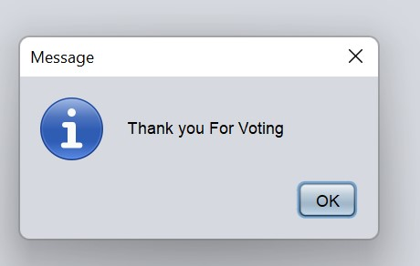

**References**

[1]Al-Ameen, A. and Talab, S. A. (2013). The technical feasibility and security of e-voting. Int. Arab J. Inf. Technol., 10(4):397–404.

[2] Hussien, H. and Aboelnaga, H. (2013). Design of a secured e-voting system. In 2013 International Conference on Computer Applications Technology (ICCAT), pages 1–5. IEEE

[3] Kohno, T., Stubblefield, A., Rubin, A. D., and Wallach, D. S. (2004). Analysis of an electronic voting system. In IEEE Symposium on Security and Privacy, 2004. Proceedings. 2004, pages 27–40. IEEE.

* [**https://www.youtube.com/watch?v=wgAjRQInzVI**](https://www.youtube.com/watch?v=wgAjRQInzVI)
* [**https://github.com/topics/voting-system?l=java&o=desc&s=**](https://github.com/topics/voting-system?l=java&o=desc&s=)
* [**https://www.researchgate.net/publication/358907608_Online_Voting_System_Using_Java_and_SQL**](https://www.researchgate.net/publication/358907608_Online_Voting_System_Using_Java_and_SQL)